Installation and Maintenance Instructions for ULTRAJOINT™

Internally Pressurized Guided Expansion Joints

1) Piping system must be adequately anchored to limit the pipe movements the expansion joint must absorb. The expansion joint should be installed close to a main anchor and should be followed by a pipe guide (within 14 pipe diameters) which prevents displacement of the line. If not installed adjacent to an anchor, then a guide is required on both sides of the expansion joint (within 14 pipe diameters). See chart on next page for intermediate guide spacing.
2) Be sure all pipelines are supported so the expansion joint does not carry the pipe load.
- Be certain that the piping configuration does not impose torque on the expansion joint.
- System movement must not exceed expansion joint capability as shown on the label. Operation beyond design limits will result in premature failure.
- Check system pressure and temperature and do not exceed the expansion joints capability as shown on the label. Operation beyond design limits will result in premature failure.
6) Expansion joint alloy must be chemically compatible with the media in the piping system. If in doubt about suitability, refer to a Chemical Resistance Data Table or contact Flex-Hose Co. for guidance.

7) Remove the flanges or end caps, packing materials, etc.; be certain that the joint interior is free of foreign material. Be certain that the joint is not damaged.
8) Align and support the piping adjacent to the expansion joint. Whenever possible, install all of the guides, supports, and anchors prior to inserting the expansion joint. The opening or length provided for the joint must be equal to the catalog or drawing length of the shipped joint. This shipped length of the expansion joint provides for the rated axial compression and extension as shown on the attached tag and in the catalog.
9) The shipping bar is tack welded or soldered to the expansion joint at the factory to insure rated movement. Do not remove this bar until the installation is complete – all anchors, guides and supports have been adjusted. Remove the restraint prior to testing and remove the tack weld. The restraint is not designed to react to pressure thrust.
10) Maintenance: ULTRAJOINT expansion joints do not require maintenance other than routine cleaning and painting to prevent external corrosion. If water is introduced into a steam system, the expansion joint must be drained to prevent flashing and water hammer.

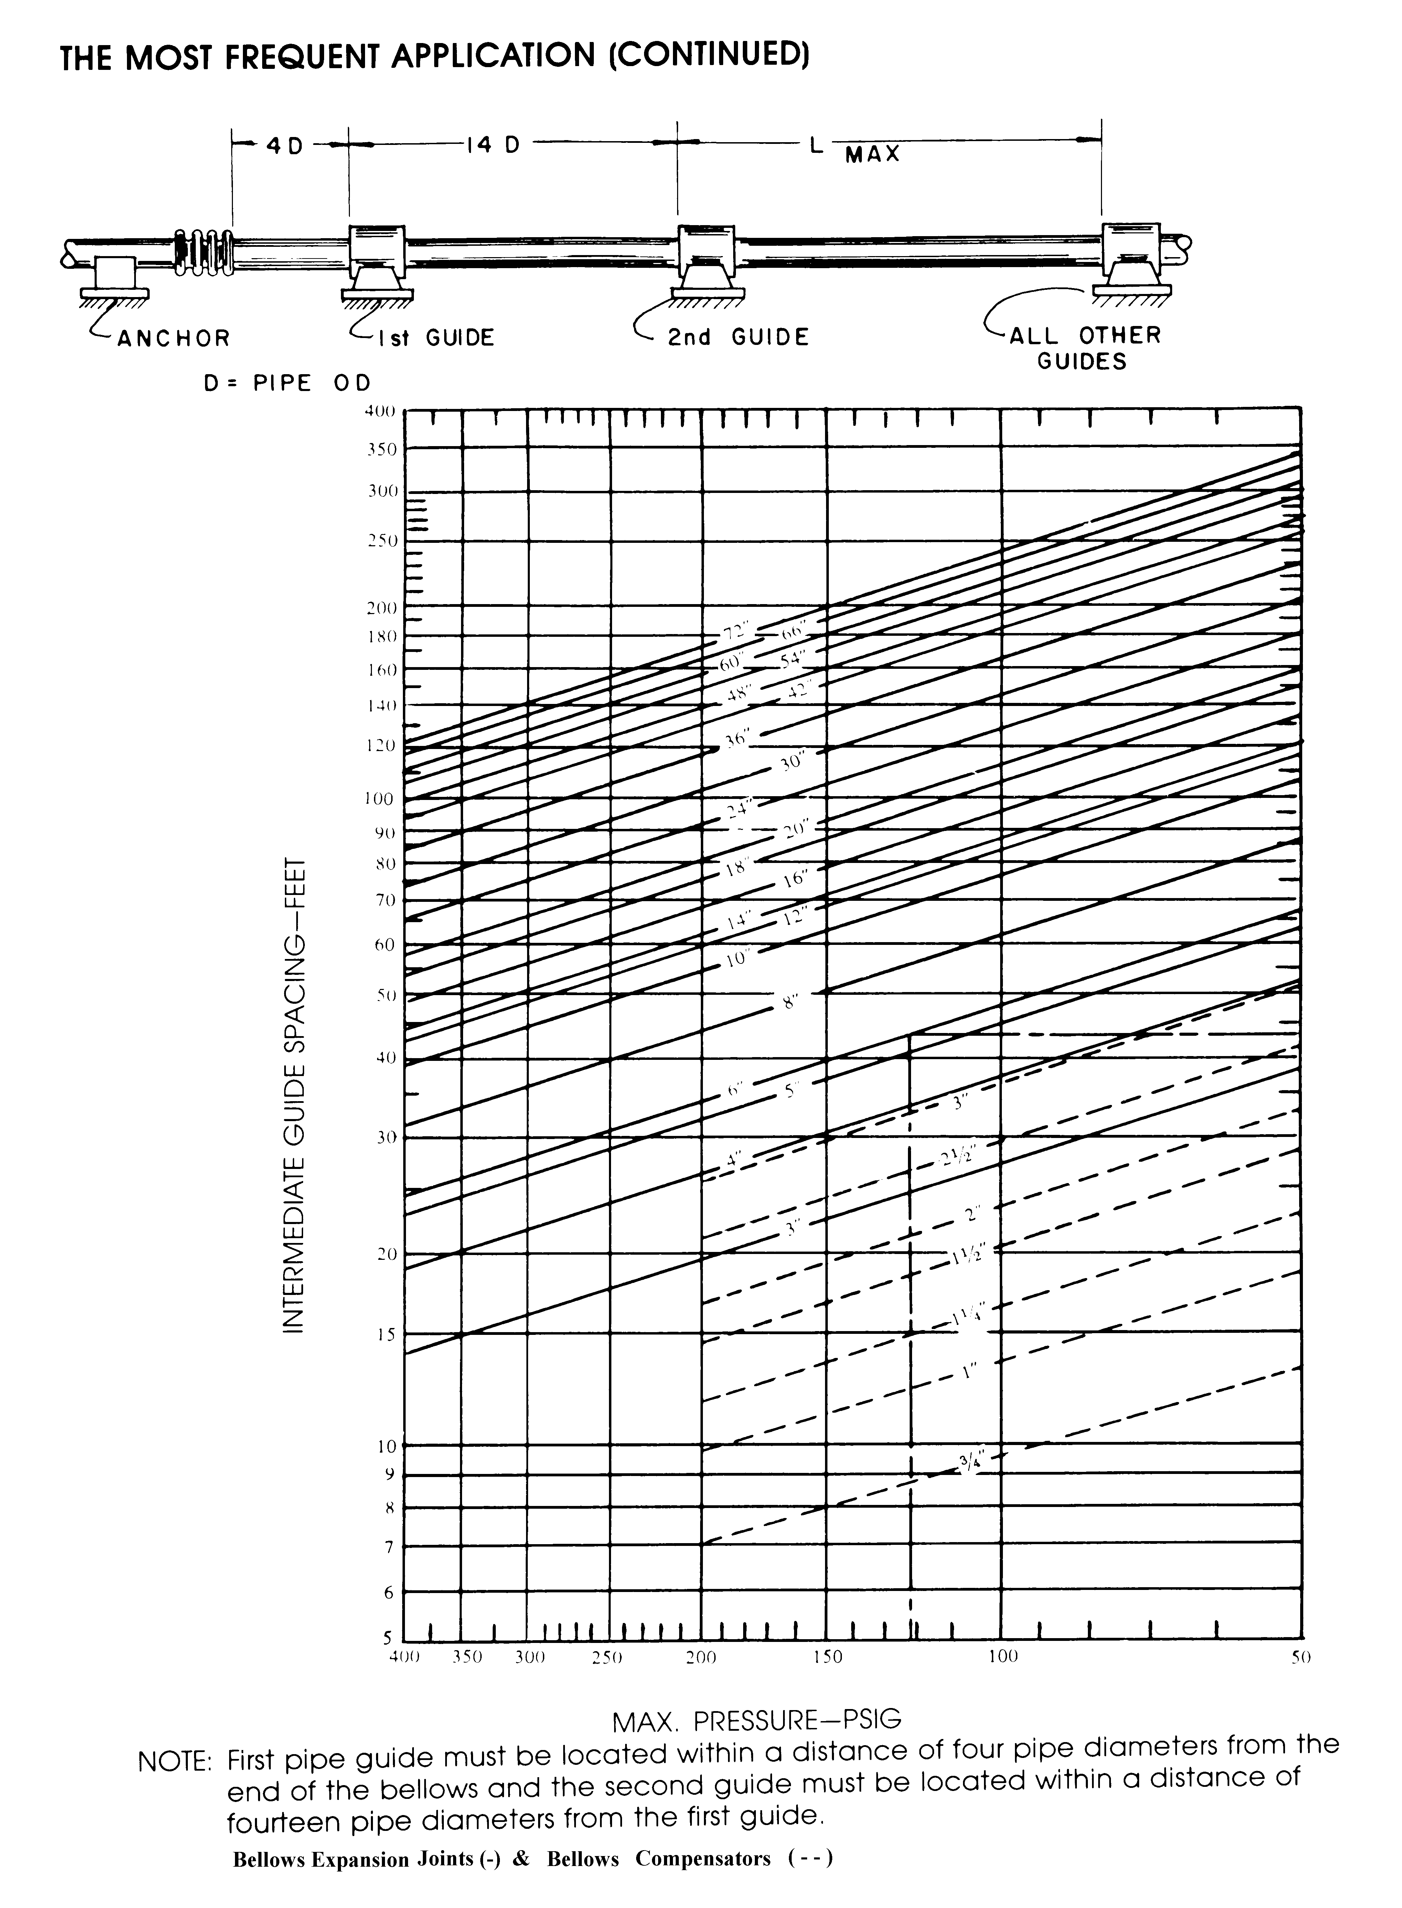

Special Note: The diagram above is for typical internally pressurized expansion joints. The ULTRAJOINT™ internally pressurized guided expansion joint incorporates an internal guide ring to direct the motion of the joint axially. Because of this feature the first guide immediately following the ULTRAJOINT™ internally pressurized guided expansion joint needs to be placed within 14 pipe diameters of the joint. After placement of the first guide, use the chart above for the spacing of intermediate guides.

